Week 2

Day 1:

Overview - Security Essentials
- metacognition : aka awareness and understanding one’s own thoughts

Key things to know
- Identify and categorize risks and threats through analysis of risk/vulnerability assessment
- Examine the threat landscape of an organization and analyze how threats may impact the organization
- Use cryptographic techniques to enhance confidentiality and integrity (C&I) of a network
- Identify patterns of attacks through log, system, and network traffic analysis
- Map the attack patterns against known threats or vulnerabilities using tools like NIST NVD and CVSS
- Assess how making changes to a network affects its CIA triad

Nature Of Risk
Must be able to predict and limit security risks, to individuals and organizations.

Reading notes
Readings of 6 to 29 pg and notes of Gallagher, Patrick D. "Managing Information Security Risk." National Institute of Standards and Technology Special Publications, (2011).

Page 15 - 40 - printed off’

What is risk in cybersecurity
Risk is a measure of the extent an entity is threatened by a negative intervention. Meaning an exploit - like code that can cause adverse impact for the business, company or individuals affected. A risk is caused by losing confidentiality, integrity or availability of data.

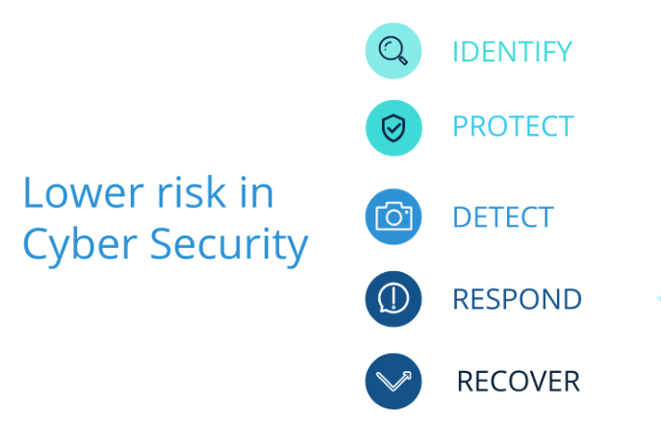
Mitigating risk
Identifying and assessing risk is the start of mitigating risk. The NIST Risk Management Framework (RMF) has recommended security actions across functions (includes identify, protect, detect, respond, recover).

NIST RMF defines steps for cybersecurity professionals to control systems while mitigating risks including the following.
- Prepare essentials, identify and predict risks
- Categorize risks
- Select key controls to limit risk
- Implement controls
- Assess if controls are effective for desired outcome
- Authorize acceptable use of controls through permissions
- Monitor ongoing controls and risk management.

Common Vulnerability Scoring Systems
Aka CVSS

Forum of Incident Response and Security Teams (FIRST)
CVSS Version 3.1 Calculator

Review questions
- If you were prioritizing variables from high to low impact, how would you compare the vulnerabilities of a national bank to a local arts nonprofit?
  - National banks have high risks and high impact but low vulnerabilities, but non profit would have high variables but low impact

- Would a national bank and a local arts nonprofit have different security risks and why?
  - National Bank would have lower security vulnerabilities but higher risk as its a larger target that's more appealing to hackers. With the bank financial and personal information is at risk and thus here ‘reward’ for criminals. However Local arts non-profit may have some financial information it wouldn't have the same amount, and have higher vulnerabilities with less risk,

Framework and Risk Management Process
Understanding risks, vulnerabilities and threats are first steps to navigating the threat landscape. RMF presents foundational info to examine how threats can impact.

Readings: Ross, Willbur L. "Risk Management Framework for Information Systems and Organizations." National Institute of Standards and Technology Special Publications, (2018).
pages v to xv, plus Chapters 1 & 2 on pages 1 to 22
- What is the purpose and function of the RMF?
- What tasks and outcomes have you identified so far?
- How does the RMF contextualize the term control?

What is Risk Valuation
A risk valuation is similar to a risk assessment. The valuation assists professionals in calculating responses to risks.
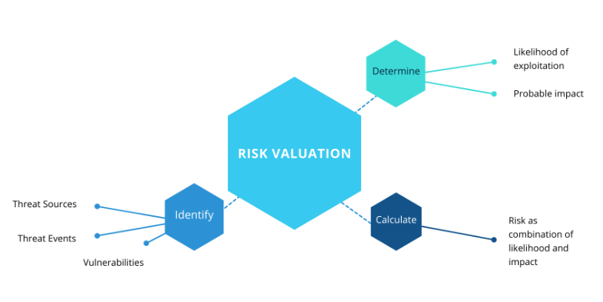
Risk valuation includes: identifying vulnerabilities, determining impact and calculating risk.
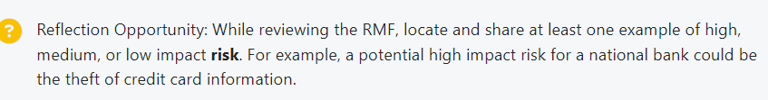

NIST RMF quick start
NIST RMF Quick Start Guide exercise - practice applying RMF.
What are the steps Cyber Security Professionals take to perform a risk valuation?

Prepare Step
https://csrc.nist.gov/Projects/risk-management/about-rmf/prepare-step
Carry out essential activities to prepare all levels of organization to manage security and privacy risks using risk management framework (RMF). outcomes are key risk management, risk tolerance determination, wide-risk assessment and common controls identified.
- RMF Quick Start Guide (QSG): Prepare Step FAQs

Categorize step
Informs organizational risk management processes and determining adverse impact with respect to loss of confidentiality, integrity and availability. Outcomes system characteristics documented, and categorization division reviewed and approved by authorization.
- RMF Quick Start Guide (QSG): Categorize Step FAQs

Example walk thoughts are here ..https://docs.google.com/document/d/1nQ0qHFKyhzFQVwwcfYH3N8QYkBzEXjEzpJdjK-pIq70/edit?usp=sharing
Example
head of cyber security for a startup company. This company's main product is an online payment processor that must securely handle customer credit card information. The company currently has only two developers, no formal security policies or procedures and the application is hosted in AWS and is accessed publicly over the internet via two dedicated web servers. The information for your current user base of 200 people is stored on a server that is directly connected to the web servers for easy retrieval.

- top 3 biggest risks to company security with explanations for your determination

- Security controls that could compensate for the company's major risks
- A strategy for implementing continuous monitoring of company source code
- Identify the company's high value assets
- Make a categorization determination around the company’s database server. If compromised - address all CIA traid

https://varonis.com/blog/risk-management-framework

—-----

Day 3:

Enhancing Confidentiality with Asymmetric Encryption

Increased data security is the main benefit of Asymmetric encryption.
Asymmetric encryption helps enhance confidentiality and protect data

Questions
- Which examples of Asymmetric Encryption are you already familiar with?
- In what instances would increased data security be critical?
- What are your first steps to building skills to enhance confidentiality?
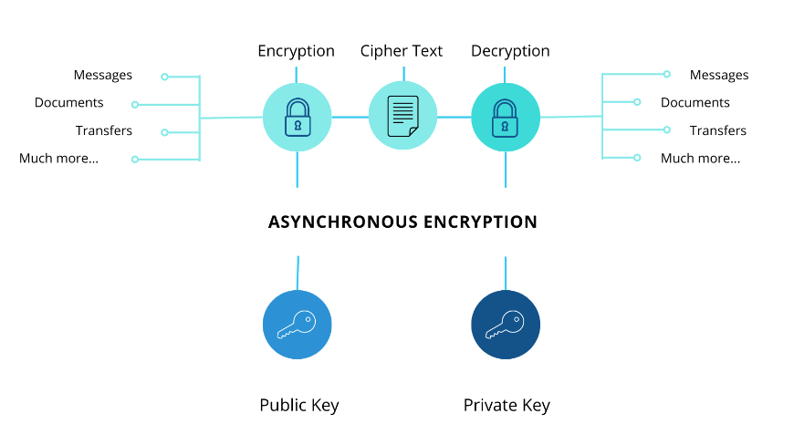
PGP = Pretty good privacy
PGP is an encryption program, able to set up public and private key exchange system. (see diagram above). The public and private key exchange system enables you to practice increasing data security

Week 3 - Python - already know

